

***Onslaught Shadowy Birthright***

**Gitlab Repo**

<http://rijeka.sdsu.edu/trentonagreen/cs583s19_2d_game_green_t_onslaughtshadowybirthright->

**Game Overview**

Title: Onslaught Shadowy Birthright

Platform: PC and Mac

Genre: Isometric Dungeon Crawler

Onslaught Shadowy Birthright (OSB)is a 2D isometric dungeon crawler where the Player is a genie, who has been teleported to a mysterious land full of ogres. The Player must defeat all the ogres and find the hidden gem to activate the portal. As a genie the Player must use fireball to defeat the enemies.

**High Concept**

OSB teleports the player into a mysterious land where they must defeat all the ogres. Use your fireballs to defeat your enemies and have a keen eye to find the hidden gem to activate the next portal.

**Game Objectives**

Objective of the game is to defeat all the ogres and find the hidden gem to activate the portal.

**Gameplay**

**Controls**

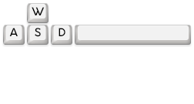

W : Move Forward

A : Move Left

S : Move Back

D : Move Right

Space : Shoot

**Camera**

The camera is an isometric viewpoint. The camera remains at a fixed angle but will follow the player as they move.

**HUD**

Player Health: Shows the health points of the player

Game Over: Only appears after losing all health points

Restart: Only appears after game over

**Player**

Player Character

The genie who has been sent here from an unknown world and must find a way home.

Metrics

Speed: 5

Health: 5

Damage: 1

States

Idle: Idle state for eight different directions, player remains still.

Move: Moving state for eight different directions as the player moves.

Shoot: Shooting state for eight different directions.

**NPC Enemies**

Ogre:

Speed: 2

Health: 3

Damage: 1

**Art**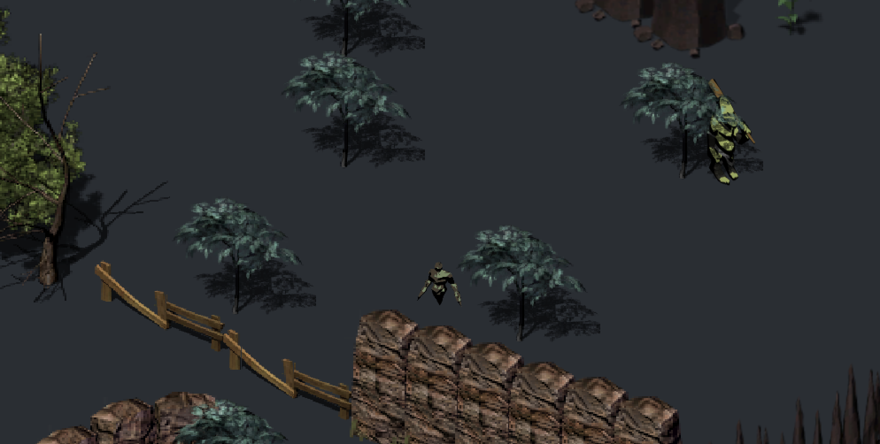

**Setting**

Game takes place in a forest surrounded my cliffs and trees. Fences, rock walls and mushrooms serve as obstacles.

**Audio**

**Background Music**

Main Menu Music: awesomeness

Level One Music: Forest_Ambience

Boss Music: battleThemeA

Credits Music: Ove Melaa – High Stakes, Low Chances

**FX**

Fireball Shoot: explode

**Wishlist**

**Enemies:**

Add more enemies and directional movement for enemies.

**Spells:**

Add different spells that the genie can do.

**Source for Audio and Art**

Image for controls - <https://opengameart.org/content/keyboard-keys-1>

Fireball FX - <https://opengameart.org/content/spell-sounds-starter-pack>

Menu background image - <https://opengameart.org/content/environment>

Boss music - <https://opengameart.org/content/oves-essential-game-audio-pack-collection-160-files-updated>

Main Menu music - <https://opengameart.org/content/menu-music>

Level One Music - <https://opengameart.org/content/forest-ambience>

**ALL** gameplay assets - <https://opengameart.org/users/clint-bellanger?page=1>

**Code References**

Menu – <https://www.youtube.com/watch?v=zc8ac_qUXQY>

Isometric Camera - <https://www.youtube.com/watch?v=XhliRnzJe5g>

Credits - <https://www.youtube.com/watch?v=cj6hwCjiVZE>